**Read Me and Test Evidence for LME Reference System**

# Usage:

Step 1:

Copy file “ins.txt” from resource package and put as C:\AppData\ins.txt, then you can feel free to edit even when the program is running.

File sample:



Step 2:

Start the program, you can enter “show” or “exit” as the input command.

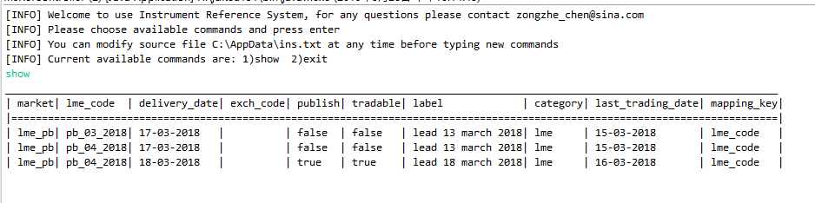

Step 3:

You can continue to input commands before you enter “exit”, and change source file at any time, the process will check file again and reload the instrument information.

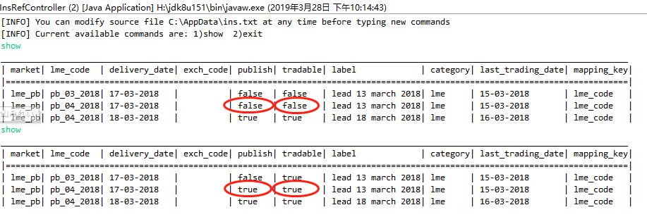

# Tests:

Junit test is enabled for this Demo to cover main functions. Currently there are 8 tests and the pass rate are 100%.

